History
Institution affiliation
Student name
Date of submission

The map of Europe in the 1300s
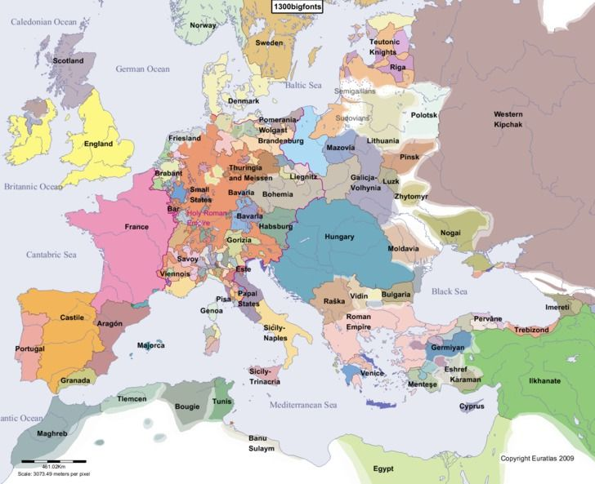

The map of Europe in the 1500s
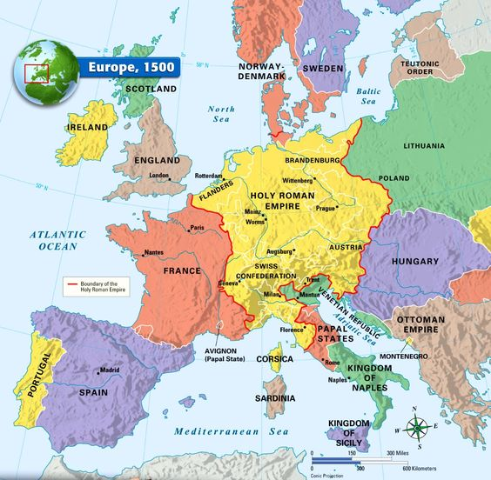

The map of Europe in the 1700s
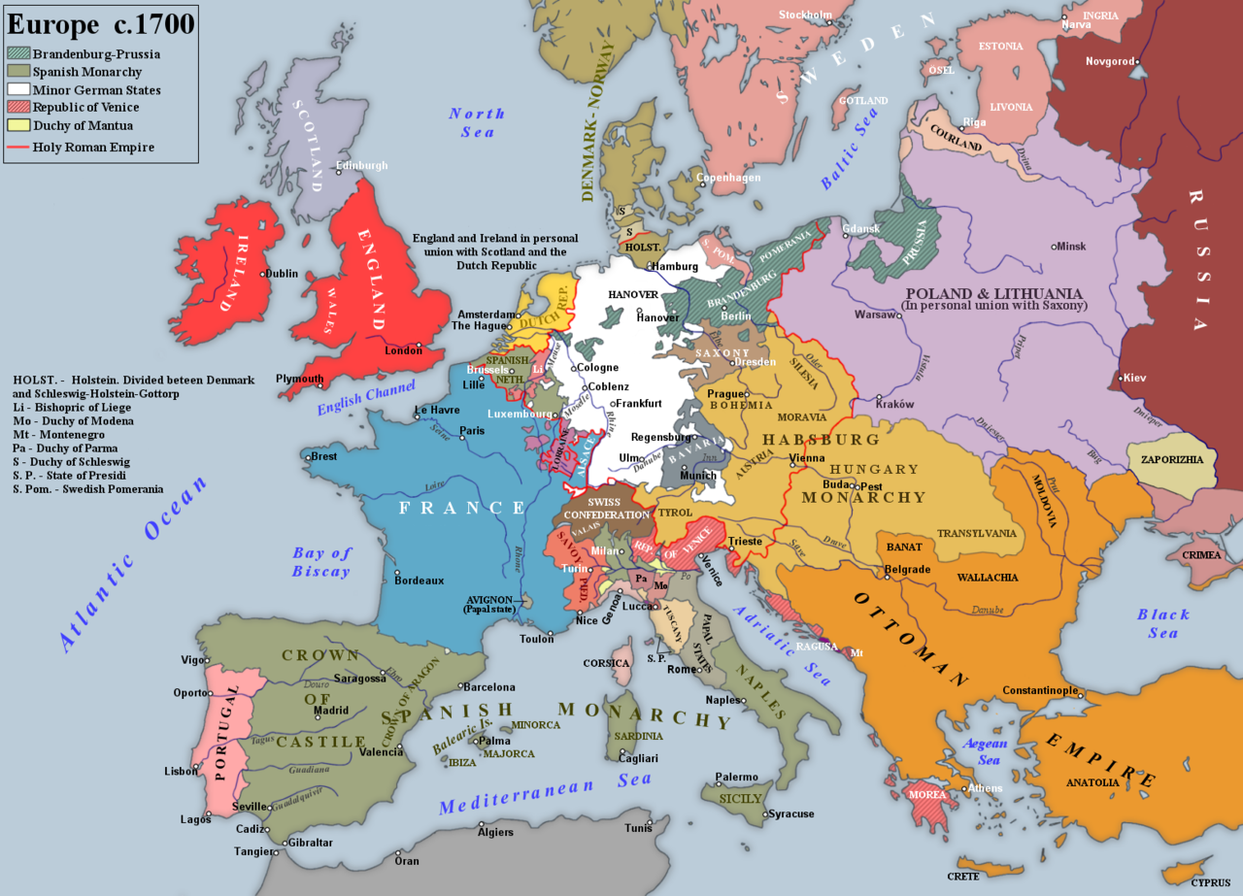

One-piece was written in old English
BEOPULF; famously known as Anglo-Saxon writing today.
One-piece was written in Middle English
The Canterbury Tales were written by Geoffrey Chaucer.
English begins first in
Britain
William Shakespeare and Lisa Simpson contributed to the English language.
The English language belongs to West Germanic language of the Indo-European language family.
Vikings added more than one hundred words in the English language, some of those words includes; Arm: Arm, Bag: Biaggi, Cake: Kaka, Child: Bairn, Club: Klubba, Die: Deyja, Egg: Eir/Egg, Fellow: Félagi, Freckle: Freknur, Guest: Gestr, Husband: Húsbóndi, Knife: Knife, Knot: Knutr, Lad: Ladd, Law: Lagu, Loose: Lauss, Mistake: Mistaka, Outlaw: Utlagi, Plow: Plogr, Race: Rás, Raise: Reisa, Rot: Rót, Saga: Saga, Same: same, Scarf: Skarfr, Sky: Ský, Slaughter: Slahtr, Steak: Steik, Sick: Syk, Sister: Systir, Take: Taka, Troll: Troll, Trust: Traust, Ugly: Uggligr, Valkyrie: Valkyrja, Viking: Vikingr, Want: Vanta, Weak: Veikr, Window: Vindauga, Yggdrasil: Yggdrasill.
French added 99words in English; Allowance – from the Old French word alouance (payment), Apostrophe – from the French word apostrophe, Attaché – from the French word attaché (attached), Apéritif – from the French word apéritif ,, Avant-garde – from the French word avant-garde, Aviation – from the French word aviation, Bachelor – from the Anglo-Norman word bacheler (bachelier in modern French), Baguette – from the French word baguette (stick), Ballet – from the French word ballet, Beret – from the French word beret, Bon voyage – from the French phrase bon voyage (have a good journey), Brunette – from the French word brunette, Bureau – from the French word bureau (desk, office), Cabaret – from the French word cabaret, Cadet – from the French word cadet, Champagne – from the French word champagne, Chauffeur – from the French word chauffeur, Chic – from the French word chic (elegant), Cliché – from the French word cliché, Connoisseur – from the French word connoisseur, Cul-de-sac – from the French word cul-de-sac (bottom of the bag/sack), Debris – from the French word débris (broken, crumbled), Déjà vu – from the French words déjà (already) and vu (seen – past participle of ‘voir’), Delegate – from the Old French word delegate, Detour – from the French word détour (from détourner), Dossier – from the French word dossier, Eau de toilette – from the French word eau de toilette, Elite – from the Old French word elit (chosen), Energy – from the Middle French word énergie, En route – from the French en route, Envisage – from the French word envisage, Expatriate – from the French word expatrier, Facade – from the French word façade, Faux, as in faux fur – from the French word faux (false), Faux-pas – from the French word faux pas, Fiancé – from the French word fiancé, Film noir – from the French word film noir (a film genre), Gallery – from the Old French word galerie, Gastronomy – from the French word gastronomie, Gateau – from the French word gateau, Gazette – from the French word gazette, Heritage – from the Old French word eritage (héritage in modern French), Homage – from the Old French word homage, Hotel – from the French word hotel, Identity – from the Middle French word identité, Illusion – from the Old French word illusion, Insult – from the Middle French words insult (noun) and insulter (verb), Irony – from the Middle French word ironie, Jubilee – from the Middle French word jubile (modern French jubilé), Kilogram – from the French word kilogramme, Lacrosse – from the Canadian French word la crosse (the stick), Laissez-faire – from the French word laissez-faire (leave things to take their course), Liaison – from the French word liaison, Literature – from the Old French word littérature, Machine – from the Middle French word machine, Magnificent – from the Middle French word magnificent, Maisonette – from the French word maisonette, Massage – from the French word massage, Menu – from the French word menu, Metabolism – from the French word métabolisme, Metro – from the French word metro, Musketeer – from the French word mousquetaire, Navy – from the Old French word navie, Neutral – from the Middle French word neutral, Nocturnal – from the Middle French word nocturnal, Novel – from the Old French word novel, Occasion – from the Middle French word occasion, Omelette – from the French word omelette, Optimism – from the French word optimism, Papier-mâché – from the French word papier-mâché, Parasol – from the French word parasol, Poetic – from the Middle French word poétique, Premiere – from the French word première, Purify – from the Old French word purifier, Recipient – from the Middle French word recipient, Rendez-vous – from the French word rendez-vous (appointment),,, Reservoir – from the French word ‘réservoir’ (collection place), Restaurant – from the French word restaurant, Ricochet – from the French word ricochet, Rich – from the French word riche, Ridicule – from the French word ridicule, Risqué – from the French word risqué, Sabotage – from the French word sabotage, Salad – from the French word salade, Sentiment – from the Old French word sentiment, Silhouette – from the French word silhouette , Solicitor – from the Middle French word soliciteur, Souvenir – from the French word souvenir (memory), Soufflé – from the French word soufflé, Soup – from the French word soupe, Technique – from the French word technique, Television – from the French word television, Tournament – from the Old French word tornoiement (tournoiement in modern French), Uniform – from the Middle French word uniforme, Utensil – from the Old French word utensile, Valid – from the Middle French word valide, Variety – from the Middle French word varieté, Vinaigrette – from the French word vinaigrette, Zest – from the French word zeste.
Towards the end of Middle English, the pronunciation changed suddenly with shorter pronounced vowels. The British, the mother country of English, contacted many people worldwide in the 16th century. The rebirth of classical learning welcomed the new phrases and words to the language. During early modern English (1600-1800), printing was invented, meaning there was a common language in print. Printing brought standardization in English, where many people learned to read, and Books became cheaper. During this time, scholars realized that the Latin language could not be comprehensively applied to English grammar, then spelling and grammar were fixed, and dictionaries wrote.
The first book to be published in English was “The Recuyellof the Histories of Troye” (A watershed moment in literary history) by William Caxton in the year 1474.
The most famous English playwright is William Shakespeare.
The 5 writers of modern English famous from 1900 to the present are; Graham Greene, Samuel Beckett, Elizabeth Bishop, Menno ter Braak, and W.H.Auden.
Countries whose first language is English are; Antigua and Barbuda, Australia, The Bahamas, Barbados, Belize, Canada, Dominica, Grenada, Guyana, Ireland, Jamaica, Malta, New Zealand, St Kitts and Nevis, St Lucia, St Vincent, and the Grenadines, Trinidad and Tobago, United Kingdom and the United States of America.
The first radio show to be broadcasted in English was “The Harding-dox of presidential race result” from KDK4 Radio Station.
The first movie in English was Roundhay Garden scene in 1888
The three current writers are; William Gibson, Jonathan Lethen, and J.K.Rowling.
Richard Wayne Van Dyke, Mary Poppins, Donald Frank Cheadhe Jr, and Michael Landon Jr are actors who speak English with an accent.

References
Bryan, E. S. (2018). Back the Way We Came! The Place of Old Norse in the History of the English Language.
Filppula, M., & Klemola, J. (2020). External Influences in the History of English. In Oxford Research Encyclopedia of Linguistics.
Gallagher, R., Roberts, E., & Tinti, F. (2020). The Languages of Early Medieval Charters: Latin, Germanic Vernaculars, and the Written Word. Brill.
Lewis, M. W. (1999). Dividing the ocean sea. Geographical Review, 89(2), 188-214.
Palmeri, J. (2017). A distant view of English Journal, 1912-2012.

